- Resolve Merge Conflicts
  - Create a merge conflict intentionally (two users editing the same line).
  - Resolve the conflict and push the changes.
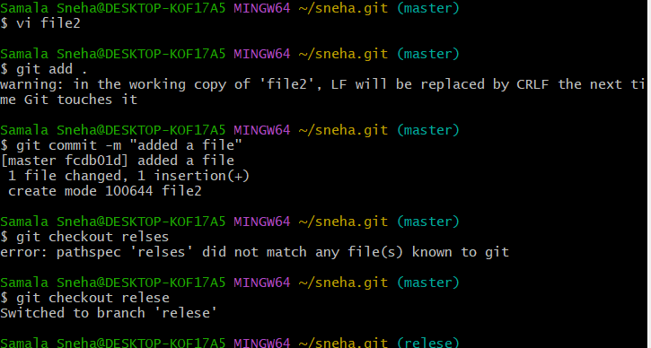
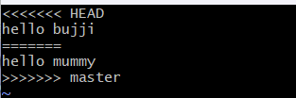

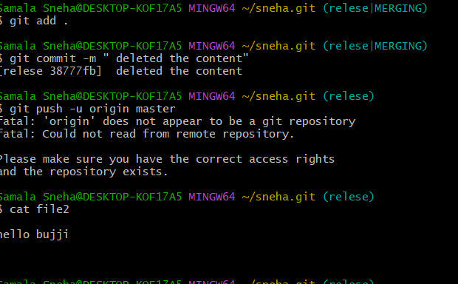
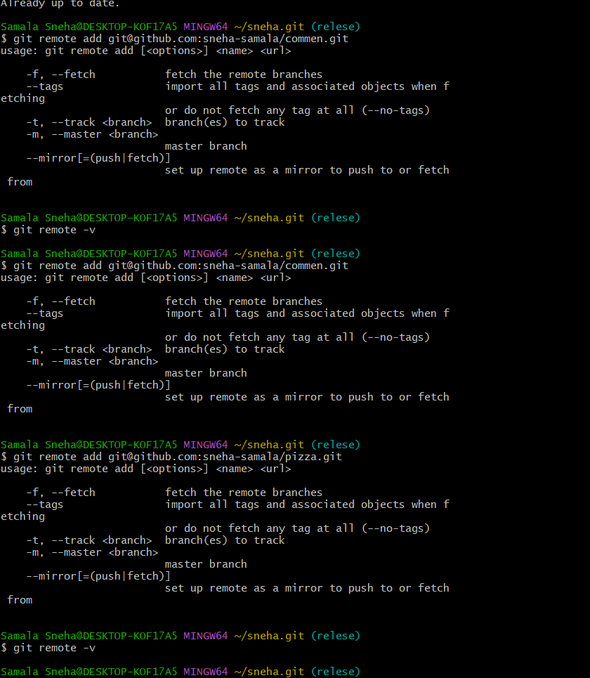
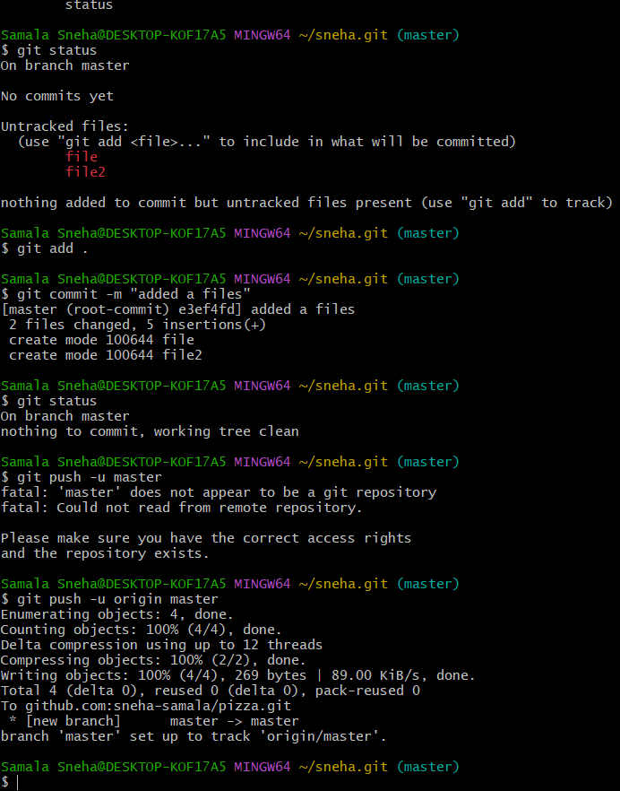
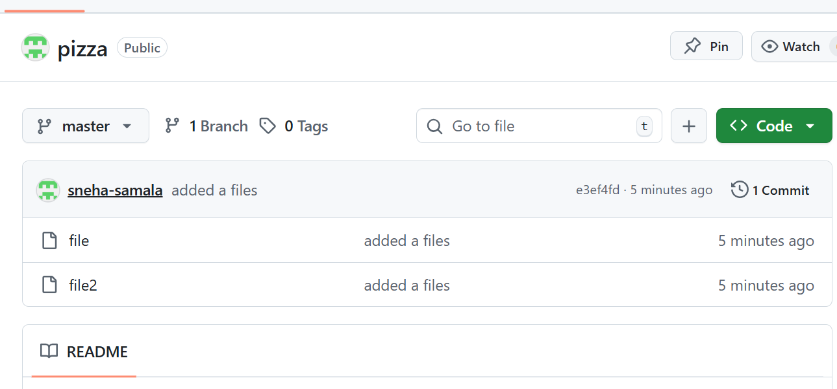
- Recover Deleted Branch
  - Delete a local branch and then recover it using the reflog.
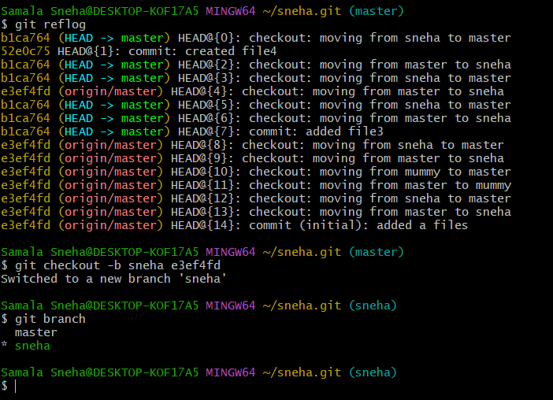

- Undo Wrong Push
  - Push a wrong commit to GitHub, then undo it without losing history.
Create file ‘
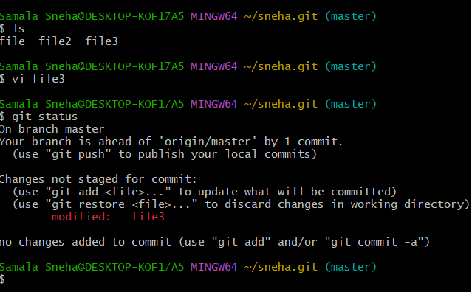
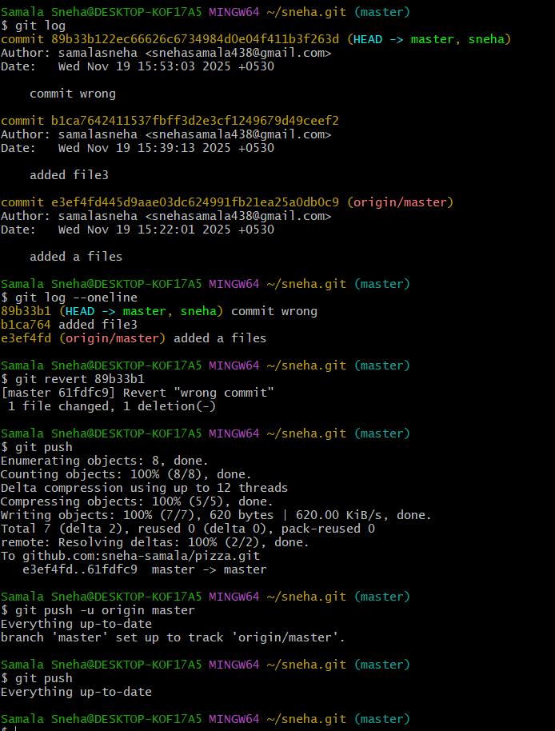
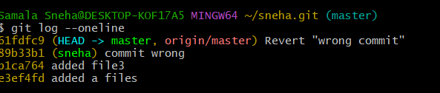
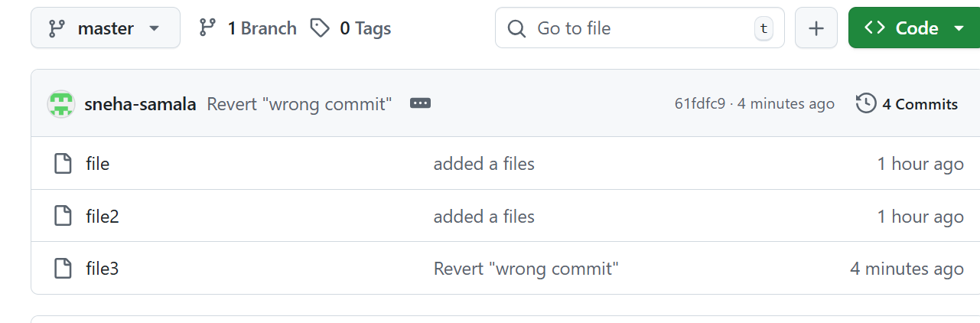
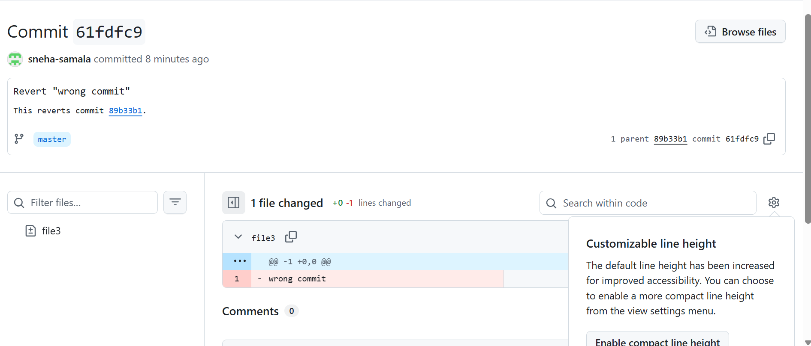

- Amend a Commit
  - Make a commit, then add a missing file to it using git commit --amend.
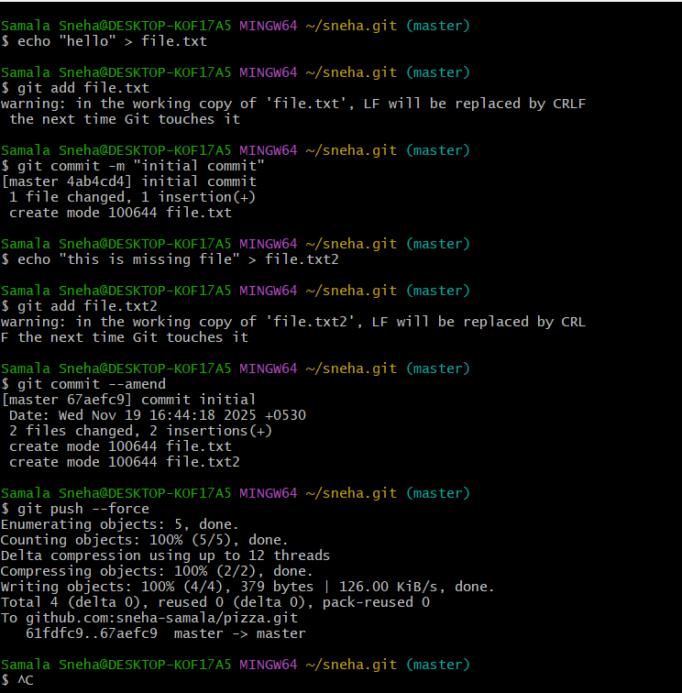
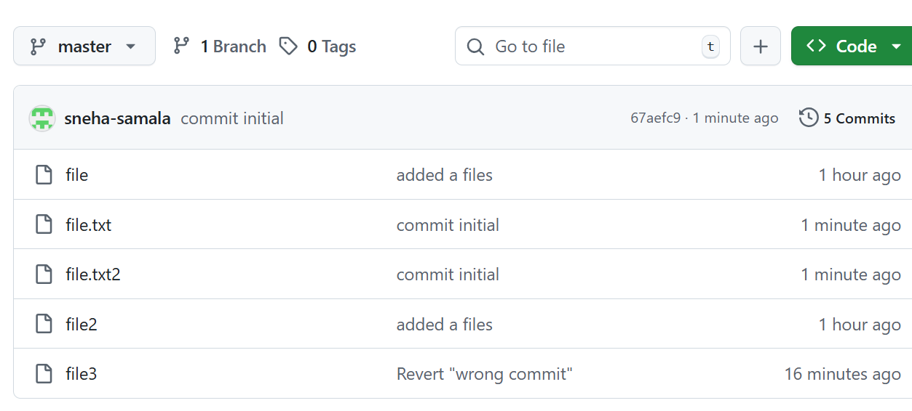
- Cherry-pick a Commit
  - Take a specific commit from one branch and apply it to another branch.
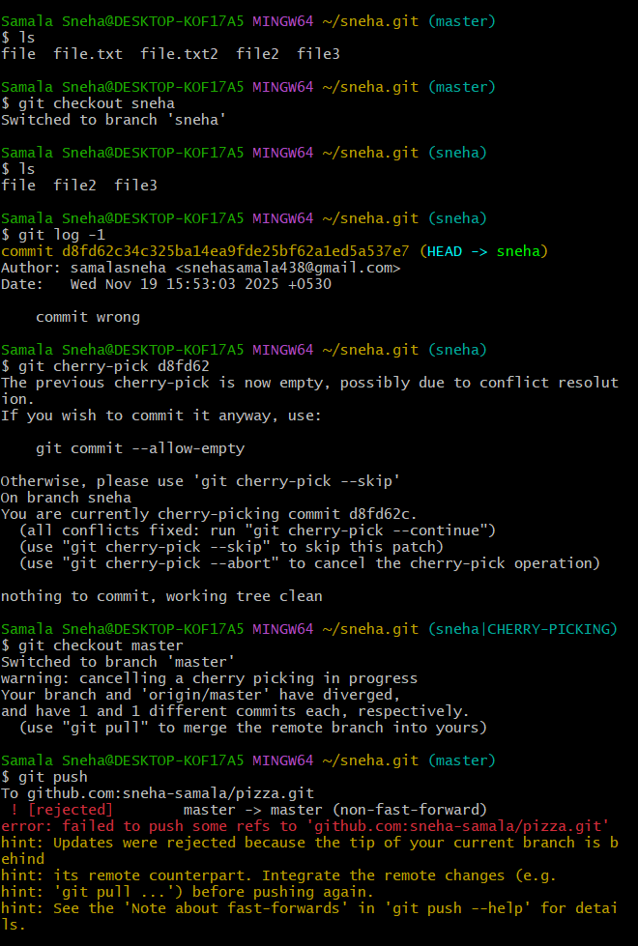
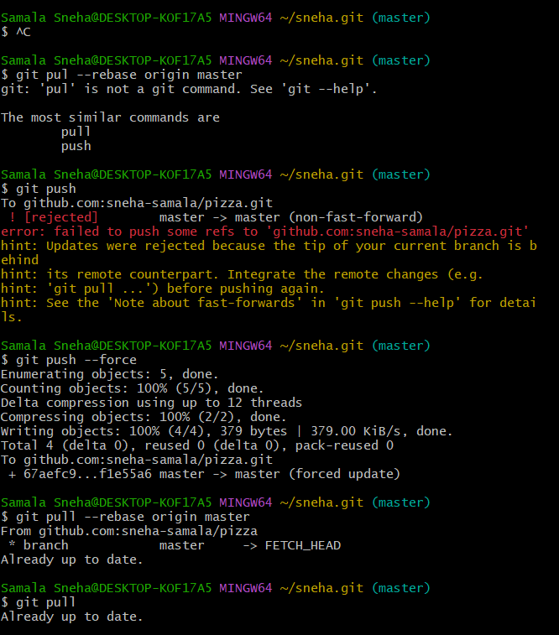
- Interactive Rebase
  - Reorder and squash multiple commits into a single clean commit.
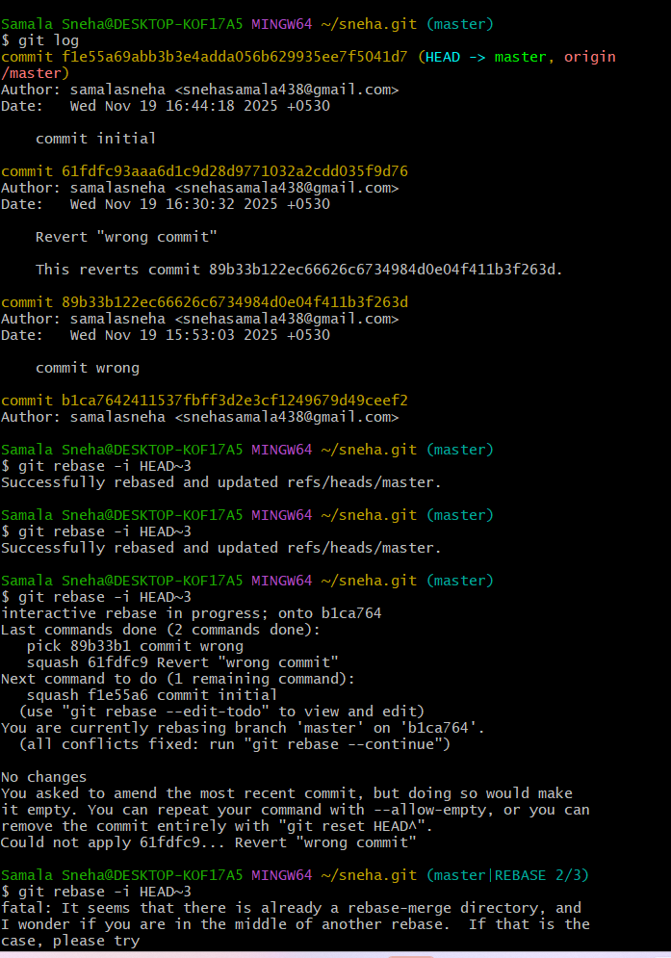
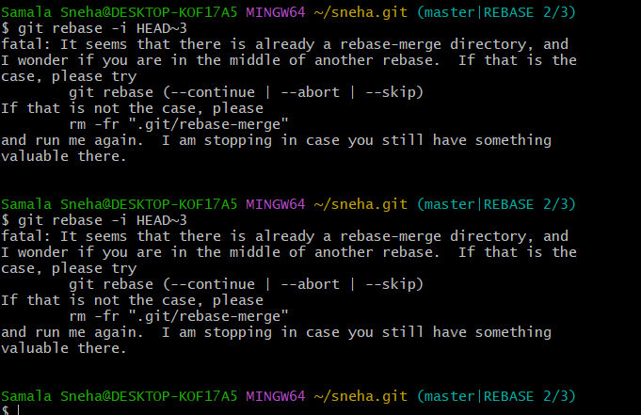
- Tagging & Release
  - Create a version tag (v1.0), push it to GitHub, then delete and restore it.
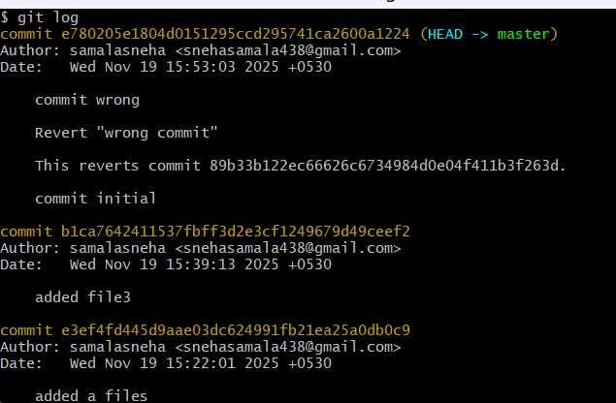
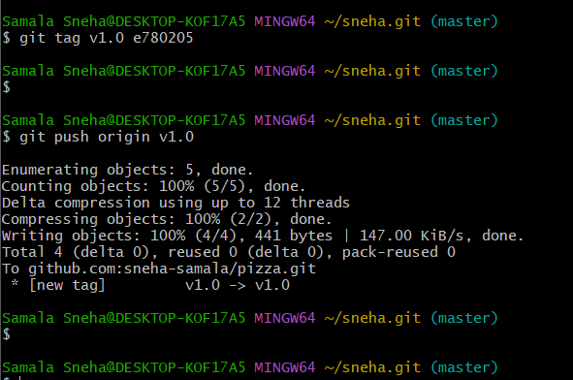
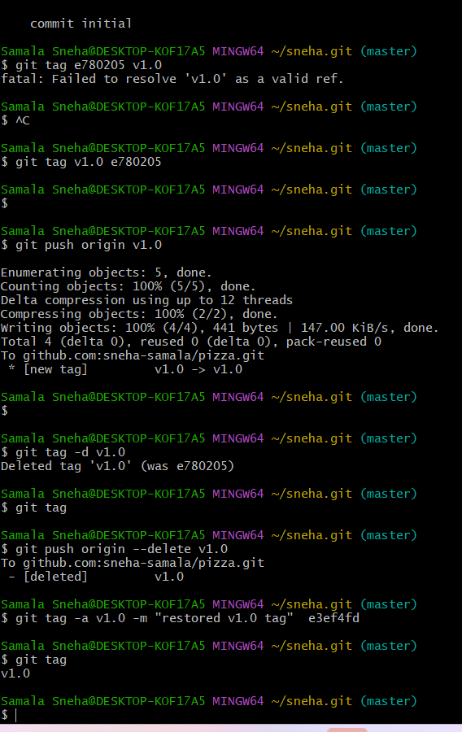
- Clone with Sparse Checkout
  - Clone only a subdirectory of a repo using sparse checkout.
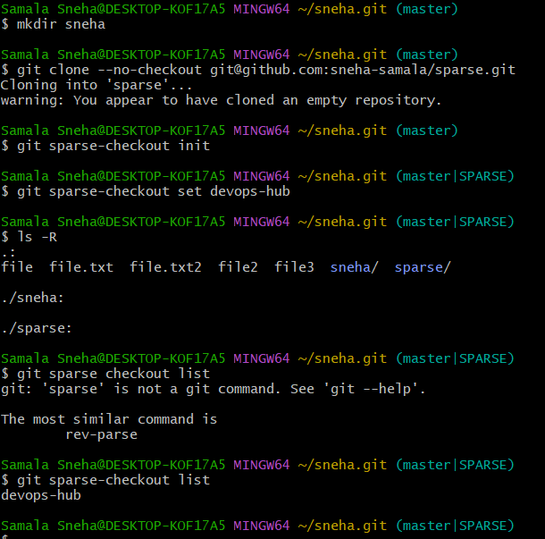
- Reset vs Revert Challenge
  - Demonstrate the difference between git reset --hard and git revert in a repo.
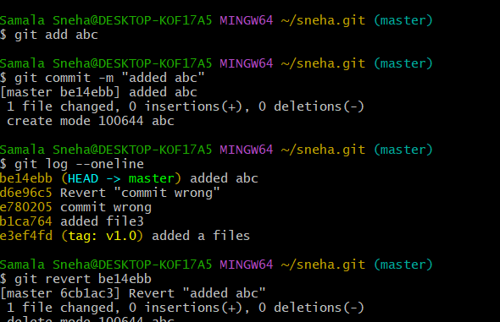
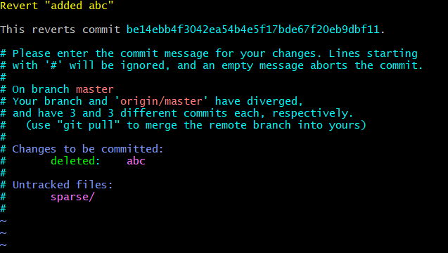

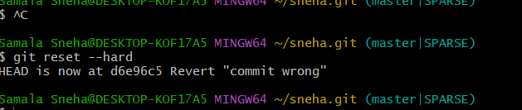
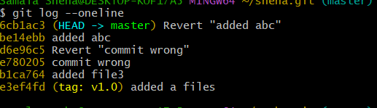
- Detached HEAD Challenge
  - Checkout a specific commit (detached HEAD state) and create a new branch from it.
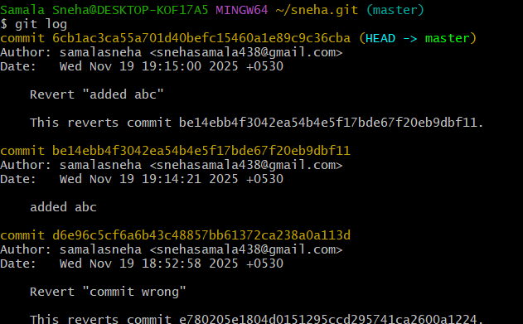
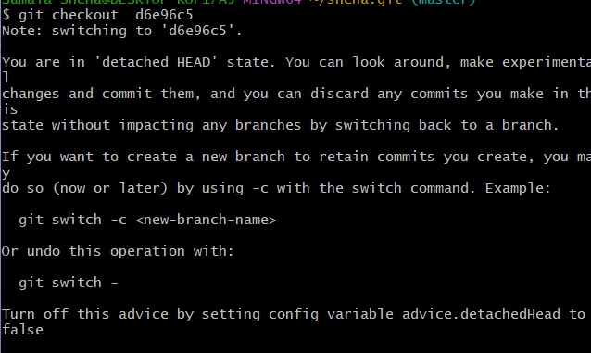
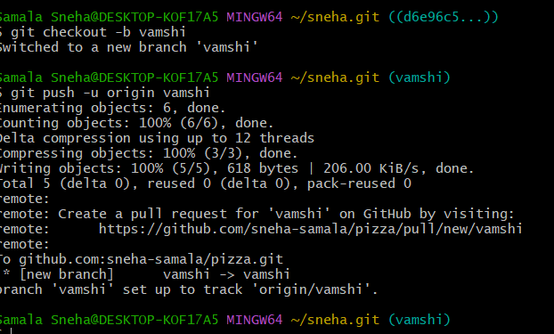
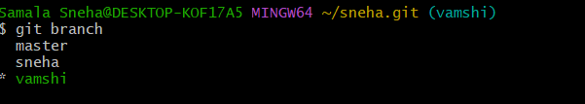
- Git Hooks Challenge
  - Configure a pre-commit hook to reject commits without a message format (e.g., must start with JIRA-XXX).
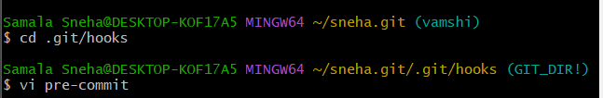
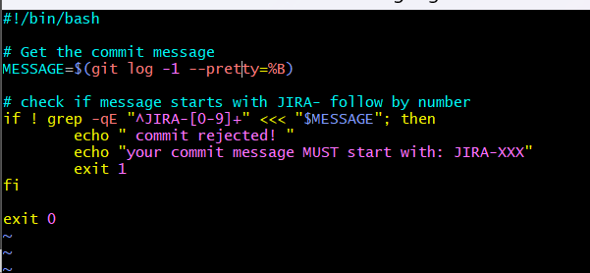
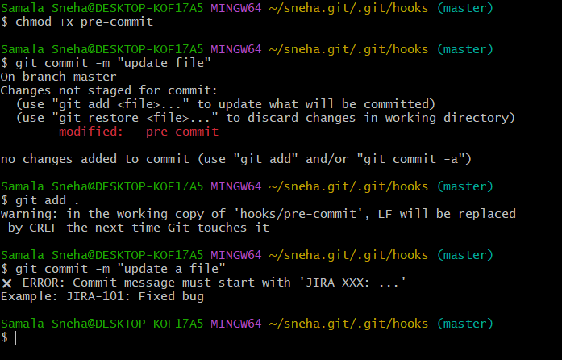

- Squash Merge vs Rebase Merge
  - Show the difference between squash merge and rebase merge with evidence.
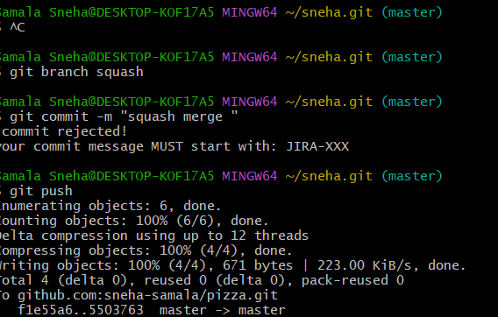
  - 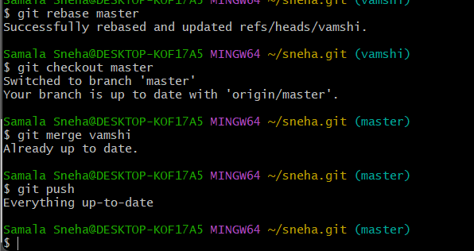
- Fork & Pull Request Workflow
  - Fork a repo, make a change, and submit a pull request to the original repo.
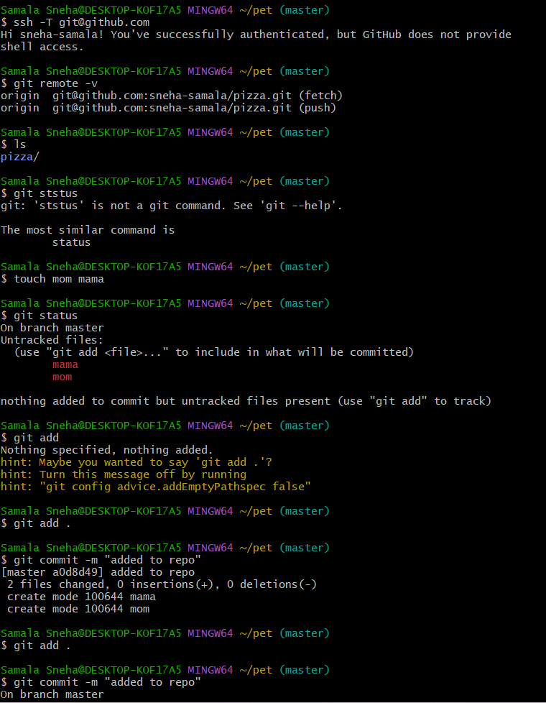
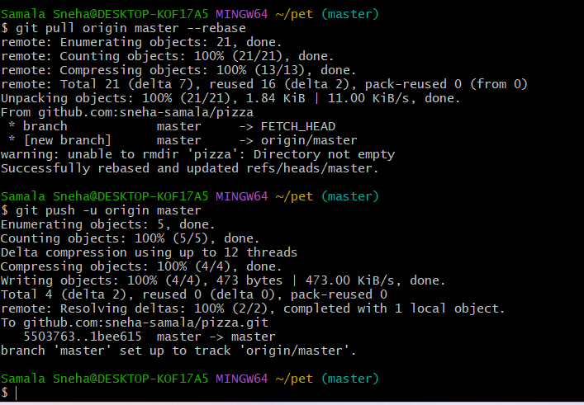
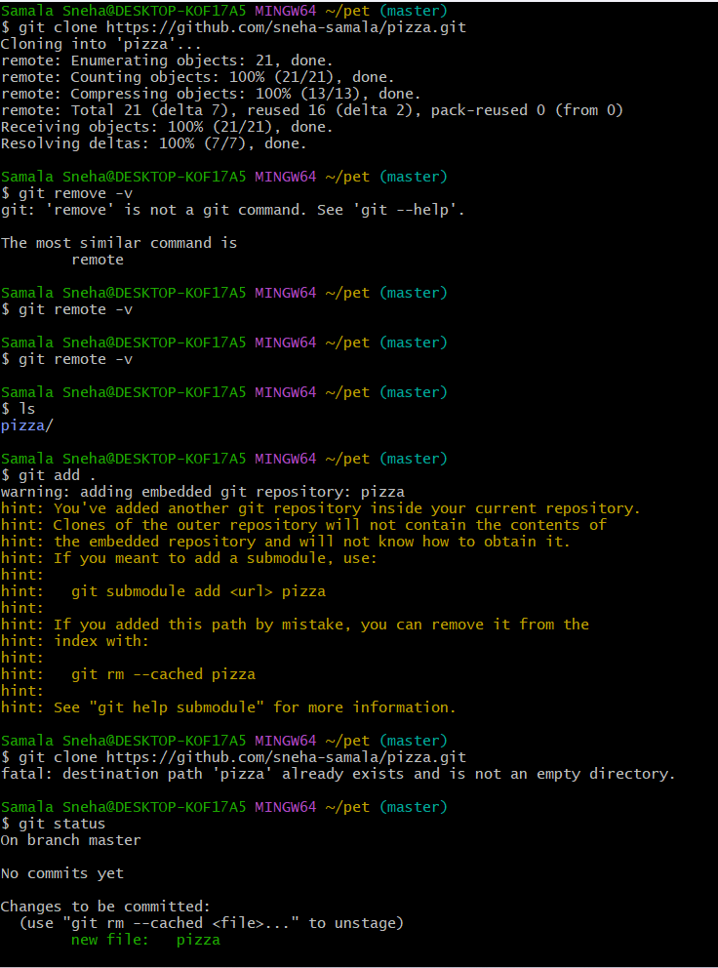
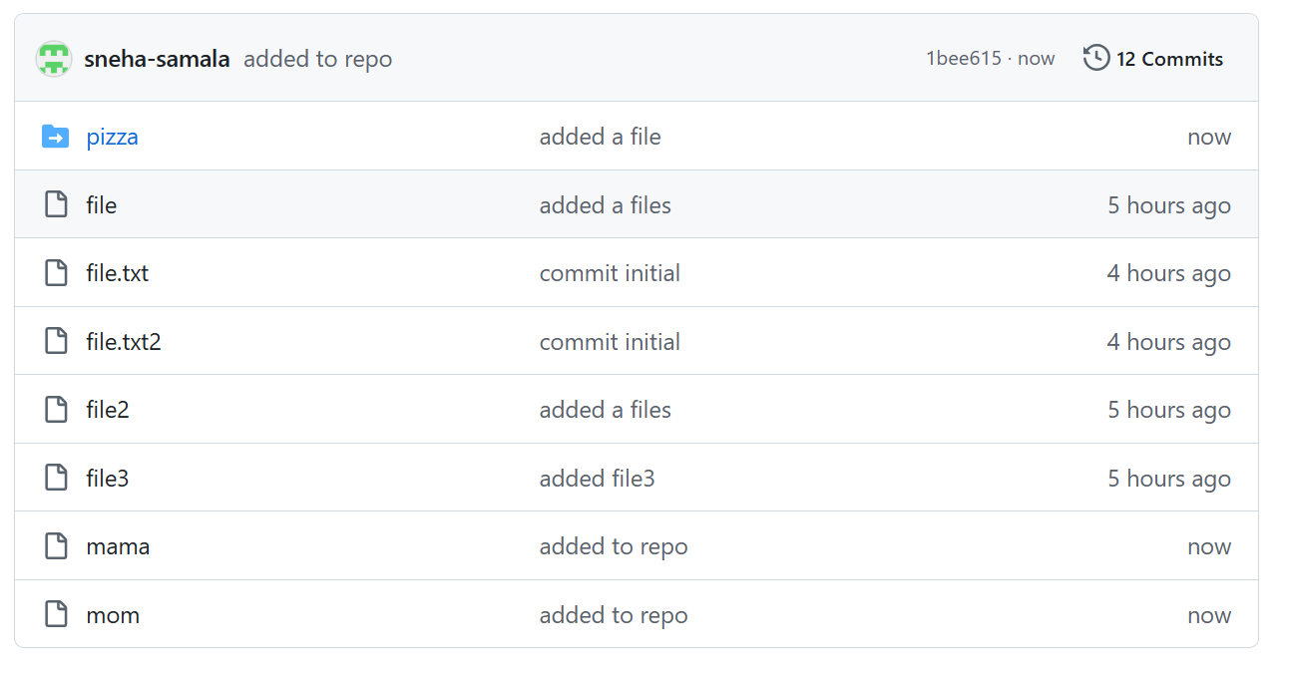

- Recover Lost Commit
  - Commit something, reset hard, and then recover it using git reflog.
